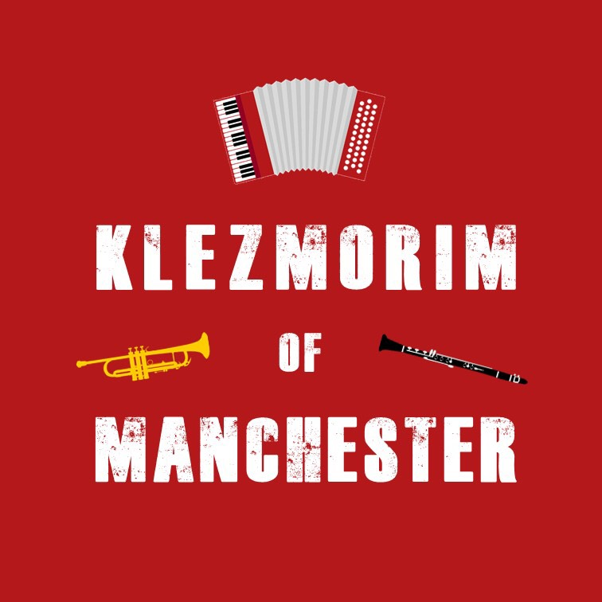
Klezmer Tune Club #11
@ The Sha’arei Shalom Reform Synagogue
Dan Mawson & Richard Fay

https://www.danielmawson.com/ktc (session resources)
https://www.danielmawson.com/ktb (tunebook)

LISTENING ACTIVITY
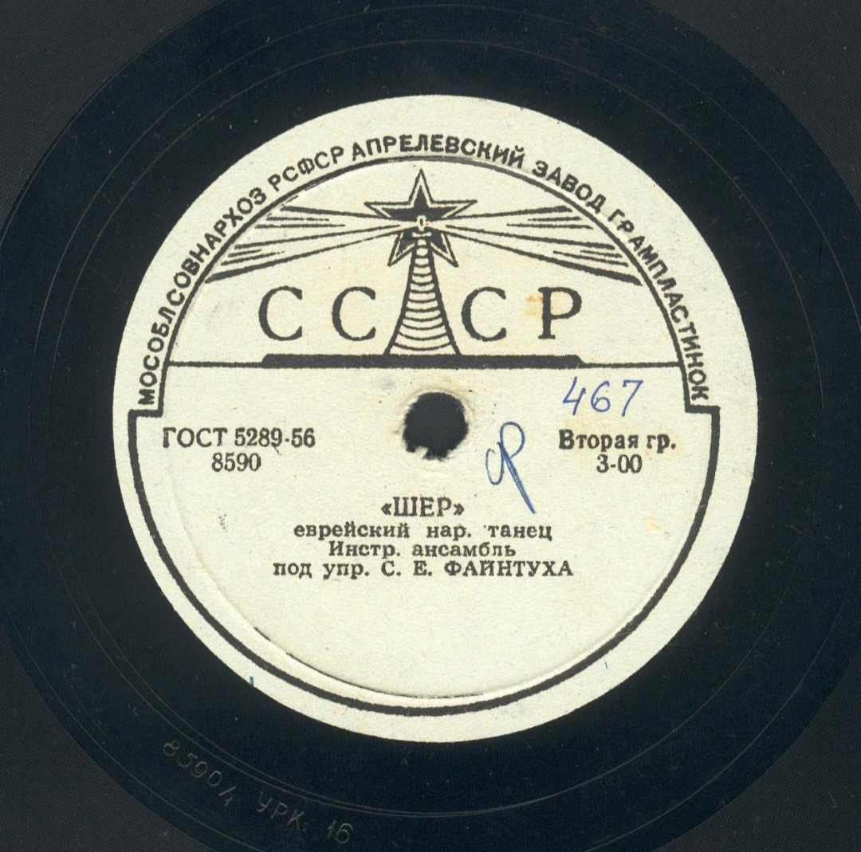
In today’s session, we are returning once more to klezmer as performed in the Old World, to a recording from 1939 (on the Gramplasttrest & Major label, manufactured in Leningrad). This recording of a Sher (Jewish dance) was recorded by the catchily named State Ukrainian SSR Jewish Folk Music and Dance Ensemble about which we do not know much.

The ensemble was founded by Moisei Beregovsky (various transliterations of his name exist), an important Kiev-based ethnomusicologist for Jewish folk material in Ukraine and neighbouring territories in the first half of the c20th klezmer. His work, which was disrupted during Stalin’s purges, has recently been explored in a film/documentary called Song-Searcher: The Times and Toils of Moyse Bergovsky). The ensemble was originally conducted by violinist Mark Rabinovich and later, after it had been reformed on more classical lines, by Solomon Feintuch (as in this recording).

First Listening

As previously, what is your first response to this tune? Is it what you were expecting? What caught your ear?

Second Listening

As you listen again, pay closer attention to: a) the structure (how may sections are there); b) the instrumentation (what instruments can you hear?); and c) the distinctive characteristics of the arrangement

The Sher - or Sherele (meaning scissors/little scissors) – is a set dance in 4/4 with a march-like tempo. It requires a set of four couples in a square formation (i.e. similar to a quadrille or square dance). The dance uses a variety of figures used (e.g. couples advancing/retiring/changing places etc). The “sher” figure involves two opposite men advancing towards each other and then crossing past each other turning as they pass, a move imitating the cutting action of scissors.

Michael Alpert (who amongst other things was a member of the band Brave Old World) describes it thus:

“The sher (also called sherele) is one of the most popular and widespread East European Jewish figure dances. Dating from the late 19th and early 20th centuries, it is similar to the American square dance, the Russian kadril [quadrille] and other urban and rural figure dances originating in northern and central Europe of the past 150 years. Calling for individual, couple and group participation, the sher functions as one of the richest venues for both social interaction and individual expression in the East European Jewish dance repertoire."

For an introduction to the dance itself, see for example:

https://www.youtube.com/watch?v=GncVzMPQB0Me

https://russian-records.com/details.php?image_id=11917
https://www.youtube.com/watch?v=_IIQtqLvtv8

