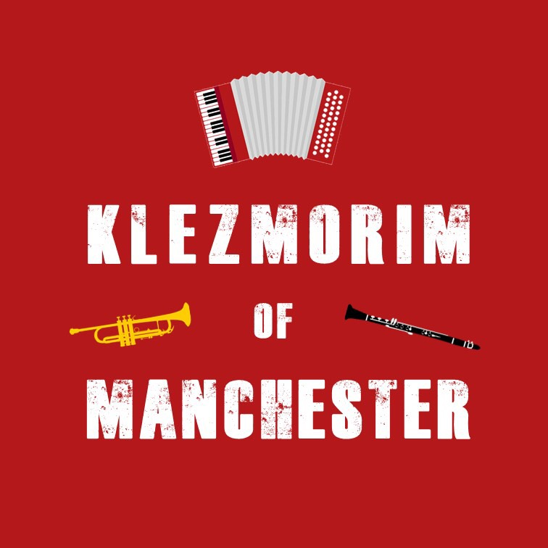
Klezmer Tune Club #12
@ The Manchester Jewish Museum
Dan Mawson & Richard Fay

https://www.danielmawson.com/ktc
https://www.danielmawson.com/ktb

LISTENING ACTIVITY

Many of the tunes we listen to and learn come from the recordings made in the USA (New World) in the early c20th, recordings which proved so influential in the klezmer-revival of the 1970s/80s led by musicians in the USA.
As a result, it can sometimes seem as if all music played in the Old World was simply unavailable to us in either written or recorded forms.
This is not the case, however. In this KTC session, we are consciously looking at a piece of music documented in what is now southern Ukraine in the early decades of the last century.

Listening

As you listen to this tune, think in both:
- macro terms (do you like the tune? Does it sound like what you consider to be klezmer? What kind of tune is it? etc)
- micro terms (how many sections are there? What is the structure? What instruments are involved? What do they do in the arrangement?)

Zusman Kiselgof – aka Susman (Zinoviy Aronovich) Kiselgof (Зусман Аронович Кисельгоф, זוסמאַן קיסעלהאָף ) – was born in 1878 and died in 1939. He was a Russian-Jewish mostly self-taught klezmer fidl player and folksong collector. He was a founding member of the Society for Jewish Folk Music (located in what was then St. Petersburg) and campaigned for a new Jewish theatre for St Petersburg. Between 1907- 1915, he made annual summer expeditions to the Pale of Settlement, including participation in the famous 1913/14 ethnographic An-sky expeditions. He recorded 2000+ Jewish folk songs and tunes. His death was linked to ill-health resulting from imprisonment in the Stalin era.

Avraham-Yehoshua Makonovetsky – aka אברהם-יהושע מאקאָנאָװעצקי, Авраам-Егошуа Маконовичский) – was born in 1872 and was acive until the 1930 although his death date is unknown. He was a Russian-Jewish klezmer fidl player violinist and a key informant to the ethnomusicologist Moisei Beregovsky.

Shloyme Zanvl Rappoport – aka S. Ansky (or An-sky) - was born in 1863 and died in 1920. He was a Jewish author, playwright (e.g. The Dybbuk), researcher of Jewish folklore, and cultural/political activist. Between 1911-14, he led ethnographic expeditions to various Jewish towns of in the pale of Settlement (in the districts of Volhynia and Podolia). These involved composing a large questionnaire (2000+ questions) and generated a vast collection of cylinder field recordings.

The Kiselgof-Makonovetsky Digital Manuscript Project (KMDMP) is an international digital humanities project to make materials collected by Zinovy Kiselgof during An-ski Expeditions, and the Makonovetsky Wedding Manuscript—long-preserved in the Vernadsky National Library of Ukraine—available for researchers, instrumentalists, and singers around the world to engage with first hand. The project seeks to use modern digital humanities tools to transcribe and translate the music and notes contained in approximately 850 high-resolution scans from hand-written notebooks (hefts) and catalogue into digital formats for further study and performance.
https://klezmerinstitute.org/kmdmp/

Szilvia Csaranko (and Susi Evans) – Fun An Altn Klezmer Heft (2023) Beautiful Music From Old Manuscripts

https://www.shades-of-folk.com/english/about-us/

Gasn Nigunim (street tunes) are pieces that accompany people as they walked between during the wedding celebrations, from the greeting of guests from other villages or taking the wedding party between venues. Although they are primarily in a zhok style, they can be more lyrical and processional and have a more traditional um-pah-pah waltz-like feel in particular sections.

(Taken from the transcription as part of the KMDMP)

The original title of this street tune is listed as “Shtey oyf mayn folk” (Arise, My People!). This is a song by a Ukrainian-born Yiddish poet, Mikhl Gordon. It was inspired by the reforms of Alexander II and by his brother-in-law Yehudah Leib’s famous Hebrew poem of the same name.
Like so many maskilim (i.e. followers of the Haskalah Jewish Enlightenment movement) of his generation, he appealed to the Yiddish-speaking folk to abandon its backward, fiercely insular, and arrogant ways, learn a proper language, and combine faith with secular knowledge. This poem/song was written in 1868.
A parody of the song also exists in the Yiddish theatre/cabaret tradition, with documentation of its existence from 1902. This parody is about a wife unhappy with her lazy husband who isn’t working at the tailors like the other men.

Shtey Oyf, Mayn Folk / Arise, My People

Shtey oyf, mayn folk, genug dir shoyn tsu shlofn
Arise, my people, for you have slept too long
Shtey oyf un makh shoyn dayne oygn ofn
Arise and open your eyes already
Vos iz oyf dir aleyn azoy a groys plog
Say what is it that has led you so astray
Vos du aleyn shlofst biz halbn tog?
That means you sleep till almost midday?
Tu on dayne kleyder, vi ale zikh kleydn
Put on your clothes as other people do
Vos darfstu di kleyder fun dayn elter-zeydn?
Why do you need the clothes of you grandparents?
Gey oyfder gas nit aroys in langn khalat
Don’t walk the streets in lengthy khalats
Zoln mentshn nit vayzn: Ot geyt an azyat.
Making people think it’s Asia here.

