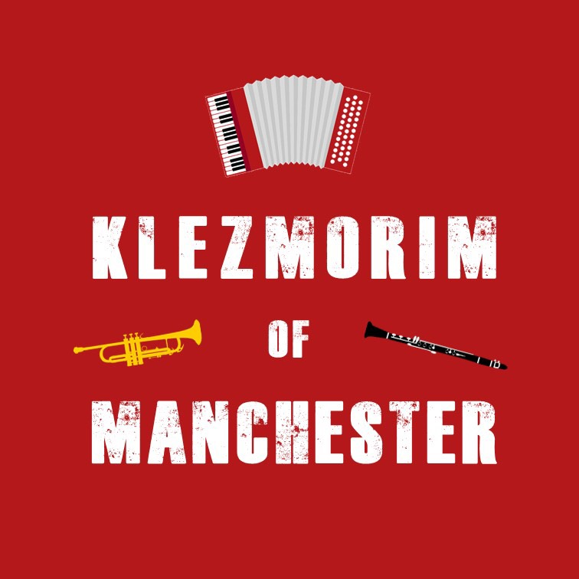
Klezmer Tune Club #2
@ The Manchester Jewish Museum
Dan Mawson & Richard Fay

https://www.danielmawson.com/ktc

LISTENING ACTIVITY

Today’s tune is a hora (a dance type, aka the limping waltz) variously called the Boybriker or Boibriker (or other variant of the name). It’s a curious tune recorded in New York in 1927 as part of a radio show ‘enactment’ in Yiddish of a Jewish wedding as it would have been in the old country (Pale of Settlement, Russian Empire). Link: https://www.youtube.com/watch?v=40sZ4yjQ6zM

First Listening

As you listen to this short / brief archive recording of the hora, what are your initial responses to it: do you like it? Is it what you expect of a klezmer tune? etc

And pay attention also to the tune: do you notice anything about its structure? What instruments are playing? Any moments or aspects stand out for you?

Second Listening

As you listen to it again, pay closer attention to:

a) its structure - how many parts are there in this tune? do they repeat? etc

b) its arrangement – what instruments are involved? What is there role? Are there any differences between the sections? Does the tempo remain the same throughout? Any rhythmic variation? etc

Notes:
A mock Ashkenazic Jewish wedding recorded by the Boibriker Kapelye including key figures in the US klezmer scene in the first decades of the c20th: Hirsh Gross, Berish Katz, Abe Schwartz, etc.

“The Boiberiker Kapelye was a Jewish ensemble – what would today be called a “klezmer” band – active in the late 1920s and early 1930s. Although now mainly cited as an early vehicle for the great clarinetist Dave Tarras, the Boiberiker was much more. Tarras plays no major role on the three 1927 Boiberiker discs, but they are classics of klezmer artistry in their own right. Indeed, the Boiberiker, with its huge repertoire, consummate musicality, creativity, and idealistic musical and cultural goals, was one of the best and most interesting klezmer ensembles ever to record. With deep roots in the conservative Hasidic traditions of Galicia and Ukraine, also at home in more modern styles, the Boiberiker was the first “klezmer band” that owed its fame to the new medium of radio. This article gives a detailed account of the ensemble’s recordings, broadcasting career, and personnel, with special emphasis on long-forgotten founder and leader Hersh Gross. It presents evidence indicating that the Boiberiker made additional recordings under other names.” Wollack article: https://klezmerinstitute.org/wp-content/uploads/2020/09/Wollock-Boiberiker-Kapelye.pdf

Dancing a hora or zhok (‘joc’): link - https://folkdancefootnotes.org/dance/a-real-folk-dance-what-is-it/1st-generation-dances/zhok-jewish-eastern-europe/
[adapted from above website] From the Romanian word for dance (joc), this dance, the so-called ‘limping waltz’ is called a Zhok or hora in klezmer tradition. This dance developed in a traditional way – not ‘taught’ by a teacher or choreographer, but ‘learned’ by observing and imitating others in your “village”, where the village’s few dances were the only dances anyone knew. It usually is ‘generic’ – the dance pattern is fairly simple and not tied to any particular piece of music. The dance phrase may or may not match any musical phrase, but the music’s rhythm must be suitable for performing the footwork. This dance may have many variations, but they’re performed at the whim or inspiration of the leader or (sometimes) any other dancer so long as it doesn’t interfere with the flow of neighbouring dancers.

C / Concert Instruments | Bb Instruments
Part A  Mode: Mogen Ovos on D  Tonic: Dm  Chord Palette: Dm, Gm , Cm | Part A  Mode: Mogen Ovos on E  Tonic: Em  Chord Palette: Em, Am , Dm
Part B  Mode: Freygish on D  Tonic: D  Chord Palette D , Cm , Gm | Part B  Mode: Freygish on E  Tonic: E  Chord Palette E , Dm , Am
Part C  Mode: F Major / Mogen on D  Tonic: F / Dm  Chord Palette: F, Bb, C / Dm, Gm, Cm | Part C  Mode: G Major / Mogen on E  Tonic: G / Em  Chord Palette: G, C, D / Em, Am, Dm

‘Waltz’ is misleading - these dances are not really in 3 time and are not played as waltzes.
Klezmer horas are a different thing from Israeli horas

