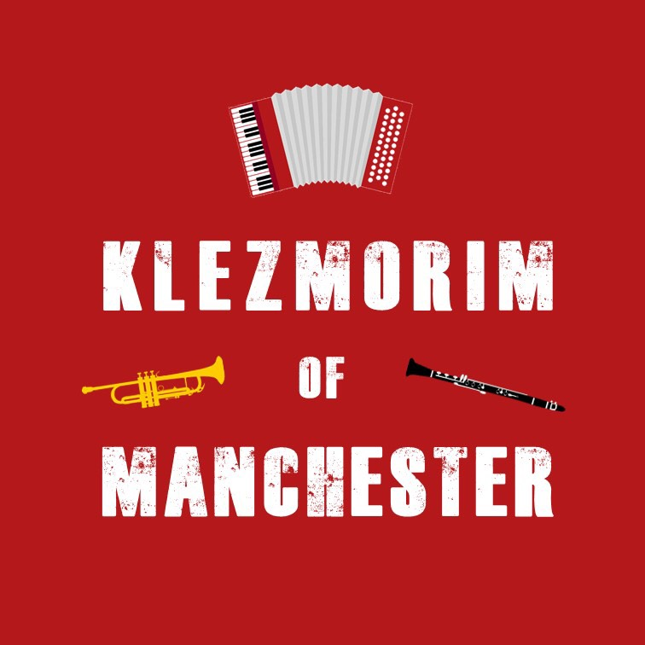
Klezmer Tune Club #5
@ The Manchester Jewish Museum
Dan Mawson & Richard Fay

https://www.danielmawson.com/ktc

LISTENING ACTIVITY
Today’s tune is variously called A Nakht en Gan Eydn / A Night in the Garden of Eden. It was first recorded in 1924 by the Harry Kandel Orchestra:
- https://search.library.wisc.edu/digital/AA54P2ERQ5D6F287/ALVFJVKEN5CND58R
It is a tune also indelibly connected to the klezmer revival of the 1970/80s and features on the documentary A Jumpin’ Night in the Garden of Eden as workshopped and performed by the Klezmer Conservatory Band (KCB) led by Hankus Netsy as based in the New English Conservatory of Music. It is also a tune reworked as part of our Amid the Mirk Over the Irk: When klezmer Meets Irish show set in Manchester in the 1890s.

First Listening
As you listen to this archive recording of A Nakt en Gan Eydn / A Night in the Garden of Eden, what are your initial responses to it: do you like it? Is it what you expect of a klezmer tune? etc And pay attention also to the tune: do you notice anything about its structure? What instruments are playing? Any moments or aspects stand out for you?

Second Listening
As you listen to it again, pay closer attention to:
a) its structure - how many parts are there in this tune? do they repeat? etc
b) its arrangement – what instruments are involved? What is there role? Are there any differences between the sections? Does the tempo remain the same throughout? Any rhythmic variation? etc

Harry (‘Chaim’) Kandel was born sometime around 1883/84/85, in Krakow (or Lviv, or Kovel) in what was then the Russian Empire. As with many biographies for that era, the details are sketchy. He came from a family involved in the timber trade, but he studied clarinet at the Odessa Conservatory and briefly served in a Russian army band. He was from the right time and in the right place to be an Old World ‘klezmer’, but as far as we know he himself was not a ‘klezmer’ prior to emigration.

Like so many of his generation, Kandel emigrated to the USA. He arrived in New York in October 1904, becoming a naturalized US citizen in 1912. He lived and worked in New York at some points, but is more associated with Philadelphia. In the US, he turned his (musical) hand to whatever was possible in his new context. He worked variously: on the popular Keith Vaudeville Circuit with the Great Lafayette Band; and on Buffalo Bill's Wild West show. He was bandleader at the Arch Street Theatre (a vaudeville and Yiddish Theatre venue in Philadelphia) and was an assistant band director and clarinettist/saxophonist with John Philip Sousa.

He also played weddings and community functions in Philadelphia, i.e. he performed as a klezmer in the new world context even though that hadn’t been part of his role in the Old World. In this klezmer role, he played alongside his Old World clarinettist contemporaries including Naftule Brandwein, and Dave Tarras. He also went into business, opening the People's Talking Machine Company, a store which sold records, sheet music and Piano rolls.

He worked for the Victor Recording Company to help develop their klezmer music catalogue, and recorded for the Brunswick and Okeh record labels - overall, he recorded around 90 sides of Jewish music from 1915 to 1927 including A Nacht in Gan Edyn. His early recording tended to be arranged for a “brassy, military-style sound” [quoting Netsky]. Pieces from this era - as arranged by Kandel and others (e.g. Abe Schwartz, I.J. Hochman, Abraham Elenkrieg) - tended to maintain some Old World arrangement and instrumentation. Often, the melodic line was played by cornet, clarinet and violin, with piano and more traditional brass, like valve trombone, providing the rhythmic underpinning. This soundscape was enriched with more New World instruments including slide trombone, banjo, and drum set. In Kandel’s case, his association with Sousa seems noteworthy - Hankus Netsky speaks of the “brass laden” sound(s) of his ensembles.

Later, Kandel experimented with a more jazzy style including Jakey, jazz ‘em up, a possible inspiration for a much more well-known swing+klezmer combination: Frailach in Swing arranged by Philadelphian trumpeter Ziggy Elman (aka Harry Aaron Finkleman) for the Benny Goodman orchestra in 1939. With additional words by Jonny Mercer, as sung by Martha Tilton, it became a hit as And the angels sing.

Harry Kandel mostly retired from orchestral work in 1924. Running a music store took up his time with just occasional live and radio performances. By the 1930s, he was running electrical appliance stores (radios and refrigerators). He died in Philadelphia on July 20 …. or 22, 1943. In his wife’s obituary, he was remembered not as a musician but as a "pioneer electrical appliance dealer".

Amid the Mirk Over the Irk: When klezmer Meets Irish
https://www.klezmerirish.com/

An Irish Night in the Garden of Eden
https://youtu.be/LtueTGCE87E

