Klezmer Tune Club #6
@ The Manchester Jewish Museum
Dan Mawson & Richard Fay

https://www.danielmawson.com/ktc

LISTENING ACTIVITY

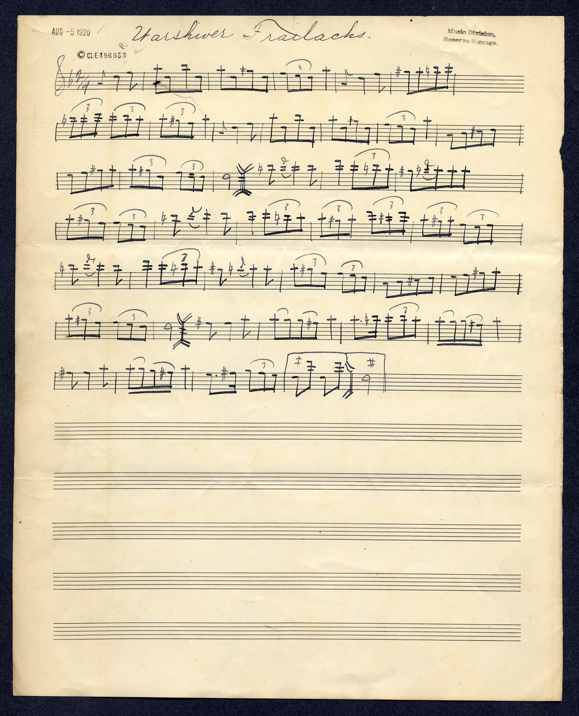
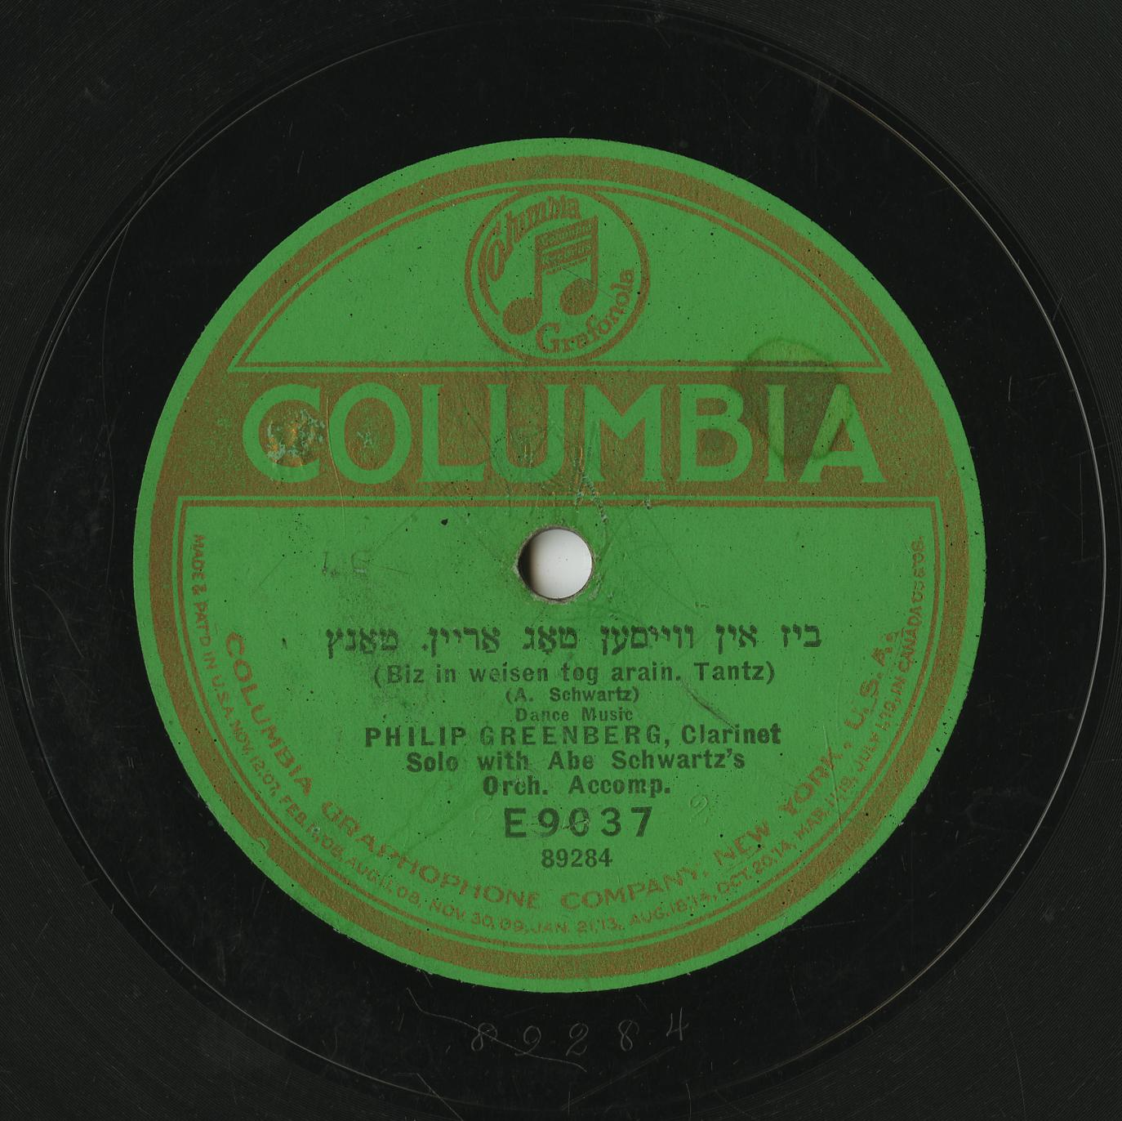
Today’s tune, Varshaver Freylekhs appears in the Compleat Klezmer collection created by Henry ‘Hank’ Sapoznik (a key klezmer revivalist amongst other things). In this volume, the tune is ascribed Abe Schwartz who was born near Bucharest 1881, emigrated to the USA around the turn of the century, and died in New York City in 1963. He was a violinist, composer, band leader, and organiser of bands for recordings by Columbia in the 1920s.

The tune is dated 1920 and that is indeed when Abe Schwartz copyrighted the piece (see image) although the tune, or variants of it already existed in print and recording.

The iconic Abe Schwartz recording -with the name Biz in weisen tog arain - is from 1923 with Philip Greenberg as the named clarinettist.

First Listening

As you listen to this archive recording of Varshaver Freylekhs aka Warshiver Frailachs, aka Biz in weisen tog arain), what are your initial responses to it: do you like it? Is it what you expect of a klezmer tune? etc

And pay attention also to the tune: do you notice anything about its structure? What instruments are playing? Any moments or aspects stand out for you?

Second Listening

As you listen to it again, pay closer attention to:

a) its structure - how many parts are there in this tune? do they repeat? etc

b) its arrangement – what instruments are involved? What is there role? Are there any differences between the sections? Does the tempo remain the same throughout? Any rhythmic variation? etc

Further Notes

Label: Columbia Matrix 89284
Artist: Abe Schwartz’s Orchestra; Philip Greenberg
Title: Biz in vaysn tog arayn (ביז אין ווייסען טאָג אַריין) (Primary title) / Biz in weisen tog arain (Alternate title)
Descriptor: Dance Muisc (instrumental)
Marketing Genre: Jewish
Date: June 1923 (2 takes)
Instrumentation: not stated

Structure:
Repeated 8-bar A (double repeated?)
Repeated 8-bar B (double repeated?)
Repeated 8-bar C

https://www.ph.unimelb.edu.au/~daewe/benkshaft/tzigas/compleat_klezmer.pdf
He is variously: an author (e.g. Klezmer! Jewish Music from Old World to Our World (1999)), performer (e.g. founder member of the revival group Kapelye), record and radio producer, and klezmer educator (e.g. founding member of KlezKamp, 1985).
Variants of the tune can be found in Kostakowsky’s International Hebrew Wedding Music (1916, reissued as the Ultimate Klezmer) named simply ‘Bulgar’ on pg 25 (pdf pg 13) and also on p.44 (pdf pg 22): https://s9.imslp.org/files/imglnks/usimg/3/34/IMSLP591846-PMLP952892-Kostakowski_1.compressed.pdf
Most notably N. Hollander’s somewhat curious 1915 solo harmonium solo recording Rumanski Bulgarish -https://rsa.fau.edu/track/5391
https://www.youtube.com/watch?v=d6wOygTuUag

