Klezmer Tune Club #9
@ The Manchester Jewish Museum
Dan Mawson & Richard Fay

https://www.danielmawson.com/ktc

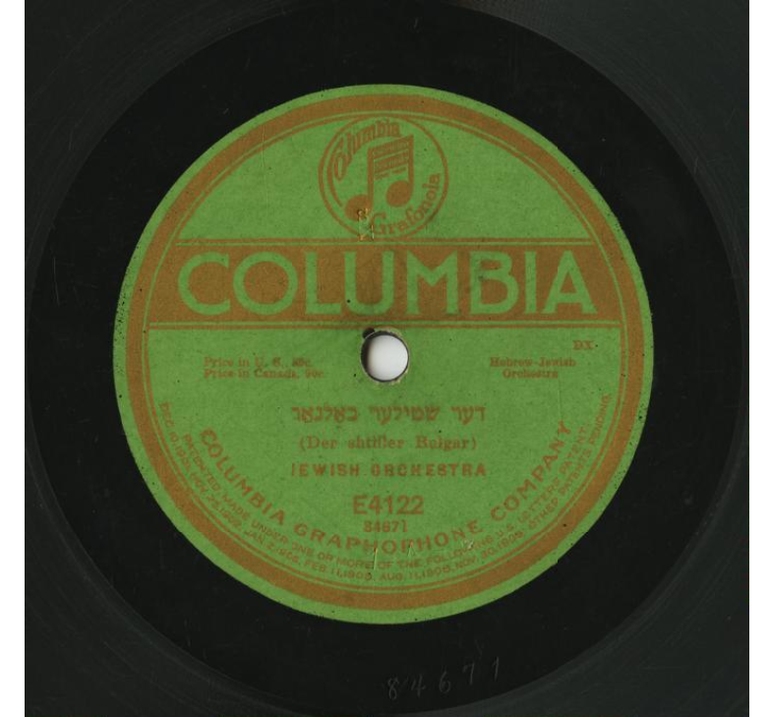
LISTENING ACTIVITY
Today’s tune, Der Shtiller Bulgar appears in the Compleat Klezmer collection created by Henry ‘Hank’ Sapoznik (a key klezmer revivalist amongst other things). In this volume, the tune is ascribed Harry Kandel (1917) although elsewhere online it is commonly associated with Abe Schwartz (1918). As we will see, it is a tune with an interesting afterlife in the space where ‘klezmer met swing’ (cf. trumpeter Ziggy Elman/Finkelstein).

First Listening
As you listen to this archive recording of Der Shtiller Bulgar, what are your initial responses to it: do you like it? Is it what you expect of a klezmer tune? Do you notice anything about its structure? What instruments are playing? Any moments or aspects stand out for you?

Second Listening
Keeping in mind the archive recording you listened to first, listen to this later version of the tune. What is the connection between them? Which do you prefer? What is your reaction to the second version? How is it structured? And arranged for what instruments?

https://www.ph.unimelb.edu.au/~daewe/benkshaft/tzigas/compleat_klezmer.pdf

